Writer: John Xaviers

**The Progressive Artists’ Group, Bombay**

The Progressive Artists’ Group, Bombay was formed in 1947 and was active until 1952. Its members were F.N.Souza, S.H.Raza, M.F.Husain, Bakre, Gade and Ara. Indian independence and the formation of Progressive Artists’ Group in Bombay (Bombay Progressives) coincided. The moment of independence can be seen in two ways; one is that of liberation from the colonial grip and second is that of decreasing friction towards western culture. Indian modern art hitherto in 1947, had been about’ Indianness’ or ‘westernness’ and the choice between the two or where it was tilting. Academic realism was vehemently denounced by this group that arose in Bombay, where there had been a strong impact of the colonial art school such as the J J College of Art. It is not surprising then that the 19th century exponent of academic realism, Raja Ravi Varma came under criticism as did the masters of academic realism in Bengal such as Atul Bose and Hemendranath Majumdar. However, it is to the Paris trained female artist, Amrita Sher Gil that these artists looked to as the main source of inspiration. Sher Gil was exemplary in the way she combined the colourism of Gauguin, Cézanne and Matisse with the legacy of the Pahari miniatures and the ancient Buddhist cave paintings in Ajanta in western India.

It is only after independence in 1947 that the dichotomy was resolved and Indian artists felt free to embrace western modernism per se. Cubo-expressionism was the style that they adopted, encouraged by the lessened burden of the nationalist question. Although it can be seen as a blind imitation of a western idiom which was at least four decades old by then, the importance of this moment is that the Indian artist was finally free to choose from anything from anywhere and was not bound by the need to appear Indian in their painterly sensibility.

PAG had a manifesto which proclaimed how they wanted to be different from all that had been happening in Indian art scene. The first meeting of PAG happened in a building in Bombay called ‘Friends of Soviet Union’ and their leader F.N.Souza was briefly associated with the Communist Party of India (CPI). At that time Souza did Socialist Realist paintings of Goan peasantry and the Bombay proletariat before turning to grotesquely expressionist painterliness; art critic Geeta Kapur observes that he would have abandoned the Communist Party for freedom now understood both in terms of personal and artistic autonomy. The PAG manifesto had one of their objectives as a, “closer understanding of art and people.” The PAG manifesto also placed emphasis on formalist elements of painting, like “aesthetic order”, “plastic co-ordination” and “colour combination.”

A lot of what the Bombay Progressives did was indebted to the cosmopolitan character of the city they were based in. Even before independence, a lot of villagers from the North as well as Southern India migrated to the bustling port city that Bombay was. There were a lot of employment opportunities, means for labourers to survive, as the habitus was in place in the metropolis, where the climate was moderate and never extreme. At the same time, it was a city where the home grown film industry was blooming, attracting the best of Urdu poets and screen writers, (including Sadat Hasan Manto who migrated to Pakistan after partition) and the best of acting talents and a lot of proficient film technicians and all the glitterati associated with the film industry. Moreover, the high life and night culture of the businessmen of the city animated its culture, which was already cosmopolitan with people from various antecedents including Parsis, Baghdadi Jews, Pathans (the infamous Pathan mafia), the British, Goan christians, Syrian Christians and the Gujarati mercantile class.

It is in this kind of cosmopolitan habitus that Bombay Progressive artists thrived. It is important to highlight the role of the ‘Times of India’ staff, Langhammer, Schlesinger and von Leyden, in picking some of these artists from random shows in the Bombay Art Society and giving them confidence, essentially acting like art mentors. In the immediate post-independent context, these white men remained in the media infrastructure of Bombay, in the landmark building of ‘Times of India’ opposite the iconic Vicotria Terminus, paving the way for the emergence of lesser-known artists, generously helping them to find their feet in the metropolis..

What is to be noted with utmost importance is that all the artists in PAG were either from a minority or dalit background. That was a welcome change in the Indian modern art world which was otherwise dominated by aristocrats (Raja Ravi Varma, Amrita Sher Gil) and *bhadralok/* Bengali landlords (Tagores, Bose, Mukherjee) with the sole exception of Ram Kinkar Baij. In PAG, Souza was a Goan christian, Husain and Raza were Muslims, Ara was from a Dalit/ ‘untouchable’ caste.

The most important guiding force of the PAG was the dynamic personality of Frederic Newton Souza who played the blasphemous genius role, utilising his Goan Christian identity. He was a very provocative painter, thinker and writer and an admirer of Frederich Nietzche and used to make controversial statements suc as, “Bombay Art Society and Bengal School must be lynched,” in his retort against the pointless debate between academic realism and *Swadeshi/* nationalist art, represented by the Bombay Art Society and Bengal School respectively. Souza primarily painted four subjects: Christ, Woman, Male Head and Landscapes/Still Lifes. To all of these themes he infused his personal expressionist style that was full of nihilistic energy. Inspired by Nietzsche, he took to anti-Christian writing and paintings and instead of painting Christ as a pleasing figure, he painted Christ as grotesque as possible. Souza was often accused of misogyny and chauvinism, for which there is ample evidence in his paintings, where the woman is pictured either as a grotesque gruesome figure or in a sexually explicit manner. Souza’s male heads became characteristically ugly creatures, which many art critics compared to frog heads. Souza was of the opinion that he wanted to show the true character of humans which was ugly and not angelic. He migrated to London at the age of 25.

However it is not that the Bombay Progressive artists did not go for any Indian antecedents or were purposefully avoiding Indian influences. It is remarkable that the Progressives came all the way to New Delhi from Bombay to see the 1948 exhibition of ancient Indian art in *Rashtrapati Bhavan*/ Presidential Palace in New Delhi (which later became the collection of National Museum) and to derive inspiration from the ancient sculptures from various dynasties across India. Especially in the early works of M.F.Husain, the *tribhanga*/‘contraposto’ figural composition as in ancient Indian sculptures can be found. The solidity of Husain’s figures and the gestural economy of his painterly scheme borrow from the *Shilpasastra*/ ‘Sculpture manual’ and *mudra*/ ‘hand gesture’ traditions of Indian dance sculptures.

Husain’s career bloomed during his years of collaboration with the PAG; later, he stayed on in India living the full national life through its ebbs and tides but was exiled by the fundamentalist right wing. Like Souza, Husain was a migrant in the city and was from minority background, but unlike Souza whose English education and blasphemous attitude and articulateness gave him an edge in the metropolis, Husain had humble origins, being a signboard painter and toy maker, and it took him years of metropolitan life to adapt as the ‘globe-trotting gypsy’ and the charismatic philandering national artist that he became, towards the end of his life.

Husain took to figurative expressionism and the themes that he chose were folk or village subjects, mythological and peasant scenes. In a panoramic painting entitled *Zameen/* Land, Husain created a symbological universe of the rural and the ancient in a grid composition with elements like a lantern, wheel, mule pack and village lady. In the immediate independence context, Husain portrayed India through tribals and peasants using folk themes in an expressionist idiom, according to art critic Geeta Kapur. She elaborates that Husain creates a ritualistic relationship between the individuals in a painting with their environment through the symbolism of the spider or the lamp and through the gestures, or bodily twists which were inspired by ancient Indian sculptures.

Husain’s embrace of the secular culture of Nehruvian India was one of the reasons why he was readily accepted by the Indian bourgeoisie. But later he ran into trouble for alleged indecent representation of Hindu goddesses which led him into a self-imposed exile to the art loving Islamic caliphate republic of Qatar. The very young art collector *Sheikha*/princess of Qatar commissioned a *Mahabharata* (Hindu epic) series from Husain.

While Indian civil society could not protect the artistic integrity of Husain, it is interesting to note that Supreme Court of India ruled that “Husain’s *Bharat Mata/* Mother India is an artwork,” in his defence, in a case where the female nudity of the anthropomorphic rendering of the Indian map was alleged to be sacrilegious and an indecent representation of women.

It is important to note another artist who was not exactly a member of the PAG, but a close associate whose works have to be read in juxtaposition with M.F.Husain, in terms of their controversial content. Akbar Padamsee, also from a minority community, was accused of indecency in a painting titled *Lovers* where a man and a woman were seated naked on a cow, but the court ruled that art is beyond social morality.

Another minority member of the PAG was S.H.Raza, who went on to become one of the most expensive artists in Indian modern art auction history, largely because of the close resemblance of his *tantrik/* ritual pattern paintings’ to American post-painterly abstraction as well as non-resident Indian demand for such paintings as a symbol of their national modernism. Raza himself is the quintessential migrant artist who arrived in Bombay at the age of 25, showed two water colour landscapes in the Bombay Art Society and was noticed by ‘Times of India’ art critic, von Leyden. After seeing some prints of Picasso and Braque in Bombay in 1948, Raza had the desire to see the originals, therefore he learnt French, obtained a scholarship and left for Paris at the age of 32. Raza made a lot of landscapes with a School of Paris influence until, at the age of 44, when he was invited to the University of California to teach a summer residency, he discovered post-painterly abstraction, which influenced his art making thereafter. One of his geometrical abstraction series with black circle is titled with a mystical Sanskrit word *Bindu/* Point, through which he connotes cosmic energy fields.

K.H.Ara was from a *dalit/* untouchable community and he ran away to Bombay at the age of 7 when his mother died and father remarried. In Bombay he was a domestic help to a European woman who recognised his talent and bought him paint. Then he worked for an Englishman, and at that time he participated in Salt *Satyagraha/* Struggle and was arrested and bailed out by his master. Later he worked as a chauffeur for a Japanese man, and after the Pearl Harbour attack, his employer disappeared overnight, and Ara looked after his house, living in the servant’s quarters, which was also his studio. This brief introduction to Ara’s story is to show how an untouchable like him could thrive in the cosmopolitanism of Bombay and find his place in the art world, to which he was inducted by von Leyden. Ara painted female nudes and still lifes, using water colour in a dry impasto technique. Once, when Clement Greenberg visited the art collection of the Tata Institute of Fundamental Research (TIFR) in Bombay, he is said to have stood in front of an Ara painting for some time and said, “Good…gracious…”

What was so progressive about the Progressive Artists’ Group was that it finally embraced Western modern art without ulterior nationalist motives. Art practice shifted from the vernacular confines of Bengal rural havens to a cosmopolitan base in Bombay. The collective spirit in which minority and *dalit/* untouchable artists got together marks a moment of decolonisation through the birth of a secular socialist republic, where the artist citizens geared up to play the cultural ambassadors.

References and further reading

Brown, Rebecca M. *Art for a Modern India, 1947-1980*. Durham: Duke University Press, 2009. http://site.ebrary.com/id/10276576.

Dalmia, Yashodhara. *The Making of Modern Indian Art: The Progressives*. New Delhi ; New York: Oxford University Press, 2001.

Kapur, Geeta. *Contemporary Indian Artists*. New Delhi: Vikas, 1978.

———. *When Was Modernism: Essays on Contemporary Cultural Practice in India*. New Delhi: Tulika, 2000.

Sinha, Gayatri, ed. *Indian Art, an Overview*. New Delhi: Rupa & Co., 2003.

Zitzewitz, Karin, and Kekoo Gandhy. *The Perfect Frame: Presenting Modern Indian Art : Stories and Photographs from the Collection of Kekoo Gandhy*. Chemould Publications and Arts, 2003.

<http://www.ngmaindia.gov.in/sh-pag.asp>

<http://en.wikipedia.org/wiki/Bombay_Progressive_Artists'_Group>

<http://www.artindiamag.com/quarter03_03_12/profiles_Shukla03_03_12.html>

<http://www.metmuseum.org/toah/hd/mind/hd_mind.htm>

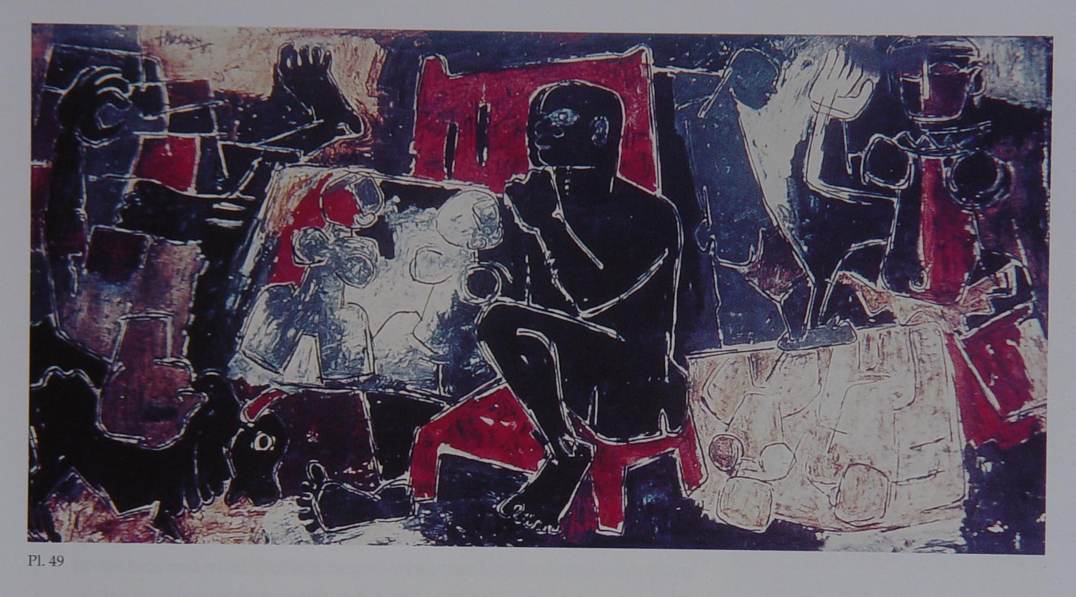M.F.Husain, *Man,* 1951, Oil on canvas, Collection: Chester and Davida Herwitz

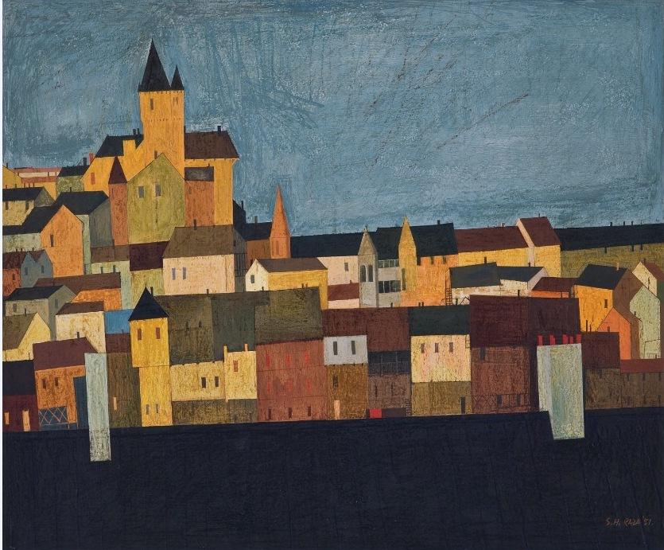[Carcassonne](http://www.knma.in/artwork/carcassonne-0)| S H Raza

Oil on paper board , 18.5 x 22 in.

1951  
Collection: Kiran Nadar Museum of Art

http://www.knma.in/highlight-from-the-collection?page=24

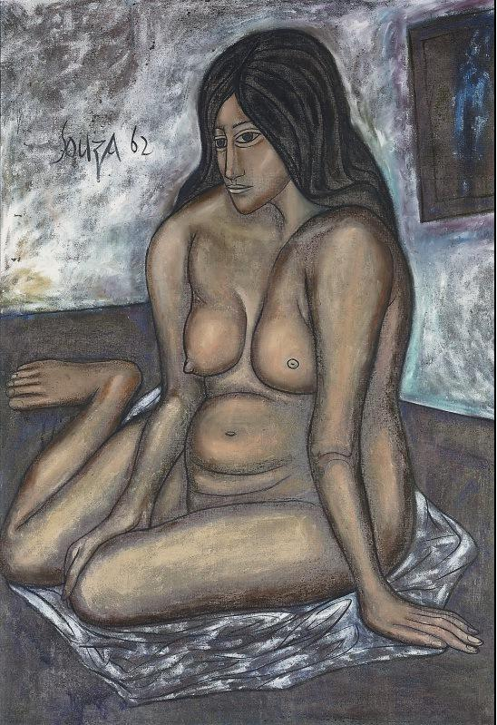[Untitled (Seated Nude)](http://www.knma.in/artwork/untitled-seated-nude-0)| F N Souza

Oil on canvas , 47.6 x 32 in.

1962

Collection: Kiran Nadar Museum of Art

http://www.knma.in/highlight-from-the-collection?page=24